NOTHING INCUBATOR
About the product:
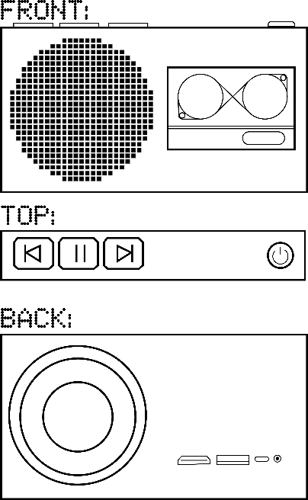
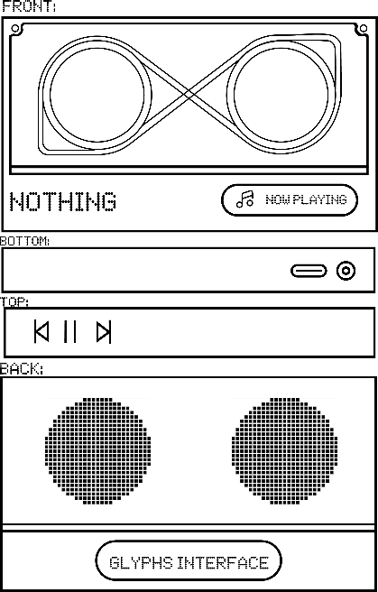
Retro-tech is arguably one of the aesthetically pleasing devices to look at, which fit in almost any environments. My proposed product is digital cassette, upgraded the design from the past to include modern features such as huge library, album cover display and more!

Figure 1 Cassette
Figure 2 Case

Features:
THE CASSETE:
- Small inbuilt storage for offline access to music
- Bluetooth pairing for connectivity with mobile
- Audio Jack support
- Dynamic Album cover display and progress bar
- Fun glyphs on the backside [waveforms, pets anything]
THE CASE:
The case builds upon the cassette, adding more functionality that is akin to a home device. Features include:
- Comparatively larger storage
- A projector at the backside
- Multi-media inputs: Options for storage of media
- Larger Speaker
AESTETICS:
Both the case and the cassette will inherit the core NOTHING design philosophy, transparent designs with overlaying shapes. The cassette itself is a sleek and handy tool, meant to be easy to take with you anywhere. It also has moving parts in the form of tapes, which is satisfying to look & increases the aesthetics to a next level. The case, slightly inconvenient to port on a daily basis. It’s best use is to put somewhere where it will be sitting for longer durations.
I think the easiest way to connect music to the cassette is use an app, that is frontend for different song distributing services (or local audio). It also has touch screen buttons on top, while the Case will have actual buttons refencing to real cassette players. The media to be transferred to the case (in-case of projecting) can be done using screen cast(app) aur pen-drives or cables.
I had so much fun designing the product and I have many future prospects for the same.
Thank You,
Ayush

